

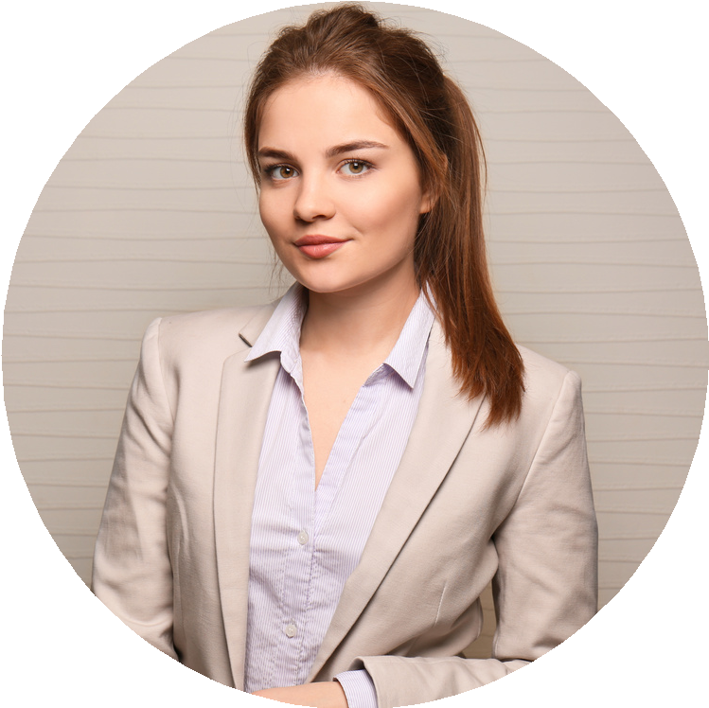
Graphic Designer
I am a highly motivated graphic designer that always aims for the best result for every project that I receive. Have many experiences collaborating with companies from various fields. With a 99% satisfaction level, I can proudly say that my works are always successfully achieving the goal that every client wants.

EXPERIENCE
Freelance F R E E L A N C E 2 0 1 0 – 2 0 1 2
Designed the banner for the local gourmet festival held in summer of 2010 and become viral after many guests share the banner image on the social media
Won the world’s amateur design competition held by Studio Shodwe and receive reward money and a year of free design online course

Team Leader S T U D I O S H O D W E 2 0 1 3 – P R E S E N T
Created a design for the company’s official jacket for the online marketing department by implementing all unique moments happened in the company’s history into one single image
Led the team to design the new promotional anniversary banner and brochure for the popular artist

EXPERTISE
Packaging Layouting 3D
Copywriting

D O N N A

S T R O U P E

CONTACT

+123-456-7890
hello@reallygreatsite.com www.reallygreatsite.com

EDUCATIONS

High school
Graduated in 2003

Borcelle University
Class of 2009 (B.F.A., Visual Arts)

SKILLS
Illustration Layout Free Hand Sketching
Typography Creativity Color Theory Patient

