MORGAN
Maxwell
G r a p h i c D e s i g n e r

About Me

Creative and detail-oriented graphic designer with 4 years of experience in developing visually compelling designs for print and digital media. Adept at collaborating with cross- functional teams and managing multiple projects to deliver high-quality results on time and within budget.

Skills: Professional Experience:

Graphic Design Typography Branding & Identity Print & Digital Media Project Management

Education:
90%
87%
95%
84%
92%

Senior Graphic Designer
June 2022 - May 2024| Fradel and Spies Company
Designed branding materials, marketing collateral, and digital assets, resulting in a 25% increase in client engagement.
Collaborated with marketing and product teams to develop visually appealing and






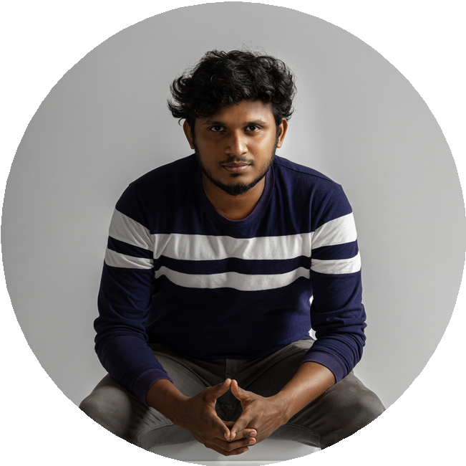
Bachelor of Fine Arts in Graphic Design Paucek and Lage University
123 Anywhere St., Any City 2016 - 2020

Language:

Russian Chinese Korean

94% 86% 84%

+123-456-7890
www.reallygreatsite.com 123 Anywhere St., Any City
effective campaigns.
Managed multiple design projects simultaneously, ensuring timely delivery and adherence to brand guidelines.

Graphic Designer
January 2020 - March 2022 | Borcelle Company
Created website and mobile app designs that enhanced user experience and increased engagement by 20%.
Led the redesign of the company website, resulting in a 30% increase in web traffic and improved user feedback.
Conducted client presentations, gathered feedback, and refined design concepts to meet client expectations.

